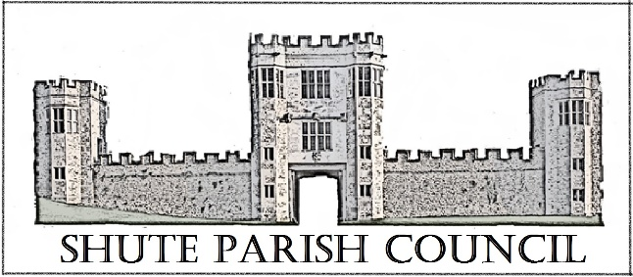

Colhayne Close, Colhayne Lane, Shute nr Axminster Devon, EX13 7QQ
Parish Clerk - Carol Miltenburg
tel:- 01404 831080 e mail:- clerk@shute.eastdevon.gov.uk

The Councillors were summoned to attend a meeting Shute Parish Council held at Shute School on Thursday March 8th, 2018 the meeting started at 7.30pm. Those present:- Councillors Bill Marshall, Richard Orsman, John Pearce, David Plowman, Peter Rugg, Ella Sweetland, Rick Wood. Carol Miltenburg – Clerk. Two members of the public – Mr & Mrs Prideaux.
Minutes

Cllr Marshall (Vice Chairman) welcomed everyone on behalf of Cllr Rugg. The following matters were discussed.

- Apologies for absence – none made at the meeting (Apologies from Cllr Magrane were received later). Cllr Marshall declared on interest in item 7 – planting.
- The Minutes of the meeting of January 25th, 2018 were received and approved byt the Council. They were signed by Cllr Marshall.
- Matters arising from previous minutes. The dog poo bin has now been installed adjacent to Whitford bridge and will be emptied three times per week. The Council was shown a photo. Parishes Together scheme – the application for funding for the purchase of asphalt buckets and equipment for the road wardens of Shute and Widworthy Parish Councils has been made. The application should be decided by EDDC in March. Common land in Shute – Clerk to write to the owner about access being restricted.
- Public Forum. Enquiries were made as to when the old telephone kiosk at the war memorial would be removed – we are still waiting for BT to arrange this. The Post Office has been contacted about the post box at the war memorial as it needs repainting. This has been noted by them and will be done when they have several in an area to do. Ashes Lane – Clerk to ascertain whether Ashes Lane is a public highway or private road. It is need of repair and is very hazardous. Clerk to thank Mr Watson and Moore for their help in clearing up the stones washed down Ashes Lane by the previous storms.
- Finance. Payments to be made – EDDC £90.00 dog poo bin; C Miltenburg - £671.77 salary & expenses; R Orsman £15.70 post for dog poo bin;.
Payments received Kilmington PC £140.00 Hitchcock Trust insurance. The Council approved the payments and noted the receipt. The bank statements were presented to the Council.
- Reports from Parish, District & County Councillors and Police – no reports were received.
- Burial Ground update. The Clerk has contacted Iris Morton the Church Warden to ascertain if the Council fund the repair of the wall between the churchyard and burial ground between the path and Haddon Road that the PCC would be happy with the Council using the burial ground side as a Memorial wall for plaques. This will be discussed at the next PCC meeting. Cllr Sweetland thought the entrance from the churchyard would be too narrow to install a gate and allow pallbearers to enter comfortably. Clerk to get quotes for the repairs. Mrs Linda Marshalls planting scheme was presented to the Council. It was agreed that £50 should be spent initially on plants. Acceptance was proposed by Cllr Orsman and seconded by Cllr Sweetland and Wood. It was agreed that the school should be contacted to ask if they would help with planting.
- Car Park. Cllr Plowman updated the Council advising that progress was slow and they are still waiting for the lease on the field to be transferred to the school. Clerk to ask DCC Highways to repaint the zig zag lines outside the school. Clerk to contact National Trust about site 3.
- Planning – 18/0428/FUL – The Old Vicarage,Shute – no objections.
- Highway Matters. Colhayne Lane – The Clerk read an e mail concerning the delay in the repairs. DCC have apologised and confirm it will be carried out in the next financial year. Cllr Marshall commented on how quick the repairs to a pothole he reported were carried out in Whitford recently. It was reported that a public footpath at Woodend Farm has been obstructed by an electric fence.
- Correspondence received. Request for grant from CAB, Honiton – the Council agreed to this. E mail from Mr Sean Taylor concerning the Stop Line Cycle Way in Whitford – Cllr Marshall will contact Mr Taylor about meeting interested parties.
- Any Other Business. Clerk to confirm signatories of Hitchcock Trust to Cllr Orsman.

The meeting finished at 8.45pm.

Date, time & place of next meeting:- Thursday, April 19th 2018 starting at 7.30pm at Whitford. This is the Annual Assembly of the Parish meeting.

