DCC Report for April 2026
For regular updated news please follow
News from Devon County Council
Could parish council please email with any work they would like me to uptake.

Additional £3 million agreed to support Devon’s road repairs
Councillors have agreed to allocate an additional £3 million for highways reactive maintenance in the current financial year.
The Cabinet’s decision today, (Wednesday 11 March), reflects the severe winter weather experienced across Devon and the impact this has had on the county’s extensive road network.
The additional funding will help address the increased maintenance pressures created by winter weather and recent storms, supporting work to repair potholes, respond to winter damage and deal with the effects of storm conditions.
Winter weather has led to a significant increase in highways reactive work across the county. For example, reported potholes in February 2026 were 9,700 – 90% higher than the same period last year.
Current projections indicate that an additional £3 million will be required this year to respond to increased demand for pothole repairs, winter gritting and storm recovery work following storms Goretti, Ingrid and Chandra.
This investment comes alongside the significant increase in highways funding already agreed for the year ahead. As part of the 2026–27 budget approved by Full Council, the council has committed:
- Over £36 million for highways maintenance, an increase of £6 million compared with the previous year.
- More than £100 million in capital investment for preventative maintenance.
Devon County Council maintains around 8,000 miles of roads, one of the largest highway networks managed by any local authority in England.

Locality Fund Opens for Applications in Mid May
How does the process work?
- Applicant contacts their local member to seek support for project.
- Applicant obtains initial support from local member.
- Applicant completes online application.
- When a new application is identified, must be double-checked with CTO to ensure complete, accurate and meets budget criteria.
- Email is then sent to local member who must approve grant and confirm amount by return email.
- Confirmation is sent to Finance to authorise payment.
- If successful applicant is emailed with confirmation.

The New Crisis & Resilience Fund, and Heating Oil Support

(CRF). This is a new Government-funded programme that replaces the Household Support Fund (HSF) and Discretionary Housing Payments (DHP).
The CRF is designed to help residents who are on a low income and experience a ‘financial shock’, and to strengthen support that helps people avoid repeat crisis in the future.
The CRF provides:
- fast, flexible help when a low-income household is facing immediate financial hardship
- support to help prevent future crises by improving financial resilience
- connections to services that can help with income, debt, housing and wellbeing
- a more joined-up approach with partners across Devon so you can get the right help through a ‘no wrong door’ approach.
The CRF isn’t:
- a guaranteed payment for everyone
- a replacement for benefits, such as Universal Credit
- a long-term income support scheme
- a scheme that can clear all debts
- an emergency service for life-threatening situations (call 999 in an emergency).
Support is targeted at people who need it most, based on circumstances at the time.
Our focus
The CRF is about more than short-term help. It also aims to support people to:
- build financial stability
- develop budgeting and money management skills
- increase household income where possible
- reduce repeat crisis situations
- strengthen confidence and independence.
This means that when you apply for crisis support, we may also help connect you to services that can provide longer-term support.
How to get help
We will publish full information on:
- how to apply
- what you may need to provide
- the types of support available
- how decisions are made
- how quickly support can be provided.

  Join the New Flood Warden Scheme
  We are launching a Flood Warden Scheme to help communities become more resilient.
  Anyone can become a Flood Warden by completing free online training provided by Communities Prepared and registering with our Flood Risk Management Team. Once trained, and registered as a Flood Warden for your community, volunteers can support their area by:
  - Helping update Emergency Plans
  - Sharing flood warnings locally
  - Acting as a link between residents and authorities
  - Supporting before, during, and after flood events
  The role is completely voluntary with no required duties — you choose how you contribute.
  Learn more on our website, Flood Warden Scheme - Devon Highways or register by emailing floodrisk@devon.gov.uk.
  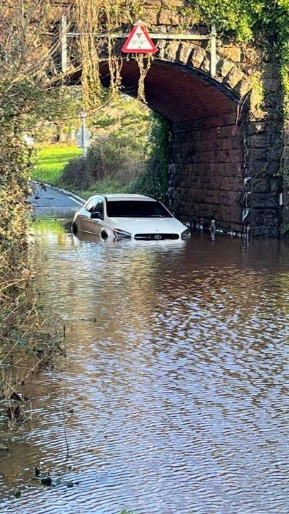

Could You Foster a Child
Being a foster carer (sometimes known as a foster parent) involves working very closely with our team of social workers to support the child’s social and emotional development. As well as caring for their health and wellbeing you will also help them keep in touch with their birth family.
As a foster carer, you will receive our generous payments and allowances, enabling you to concentrate on being the best carer possible with the financial backing that comes with such a rewarding profession.
You will also receive ongoing professional support and high-quality training.
Please see attached poster that could be printed out and displayed on village noticeboards or put in parish magazines.
Councillor Cathy Connor
Whimple and Blackdown
31/03/2026

