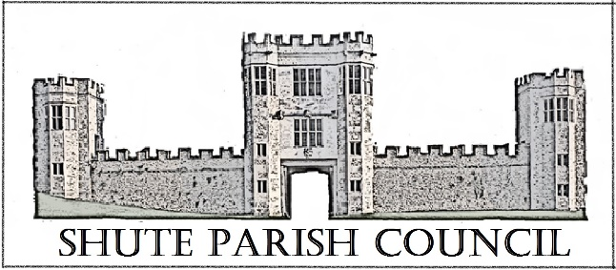

Colhayne Close, Colhayne Lane, Shute nr Axminster Devon, EX13 7QQ
Parish Clerk - Carol Miltenburg
tel:- 01404 831080 e mail:- clerk@shute.eastdevon.gov.uk

The Councillors were summoned to attend a meeting at Shute Parish Council held at Whitford Hall on Thursday May 19th, 2022 starting at 7.30pm. The following matters were discussed.
Those present:- Cllrs Angela Choake, Bill Marshall (Chair), David Plowman, Ella Sweetland and Carol Miltenburg (Clerk).

Annual Meeting of the Parish Council

- Cllr Marshall agreed to stand again and was duly elected Chair and signed his of Acceptance of Office document.

- Cllr Sweetland agreed to stand again and was duly elected Vice Chair. She signed her of Acceptance of Office document.

- Election of other Representatives. Trustees of Hitchcock Trust; Planning Committee; Burial Ground Committee; Due to the number of Councillors present it was agreed to continue as present with a view to change at coming meetings if needed.

- Apologies for absence were made by Cllrs Paddy Magrane, Richard Orsman and Mary Thomas and also Iain Chubb (EDDC & DCC). No declarations of interests were made for this meeting.

- Minutes of the meeting of April 21st, 2022 were approved and signed by the Chair.

- The Council received the Parish Council annual accounts. a) The Council approved the Annual Governance Statement (Section 1) and this was signed by the Chair. b) The Council approved the Accounting Statement (Section 2) and this was signed by the Chair. c) approval of the accounts for the year 2021/2022. c) The Council acknowledged and accepted the annual Internal Audit Report. D) The Chair signed the Certificate of Exemption for AGAR 2021/22 on behalf of the Council.

- The Council received, accepted and agreed to adopt the following documents which have been updated. a) Standing Orders (revised 2020) b) Financial Regulations (revised July 2019) and c) to adopt Council's Code of Conduct Policy (revised 2022) for the year 2022-23.

- Review Insurance cover. It was agreed to accept the offer from Gallagher and to fix the cost for 3 years. The new policy requires a risk assessment to be made of the Whitford Common with respect to the river. Clerk to check with Mrs Loud to see if Pump Farm own the river and also other Councils with land with a river for the format of the assessment. The asset register was agreed and it was agreed to review the Burial Ground charges at the next meeting.
- Matters arising from previous minutes. Covered elsewhere in the minutes.

- Public Forum. None present.

- Finance. Payments made – Whitford Hall £14 hire, Gallagher £351.66 insurance. Payments received VAT refund £644.93. These were approved by the Council.

- Reports from Parish, District & County Councillors and Police. None.

- Burial Ground. Cllr Choake reported that he Church’s quinquennial report will be undertaken in 2023. Crimson Victoria apple tree – it was agreed to plant this to coincide with the opening days of Shute Barton and church in the autumn. The Council discussed the writing up of the Burial Book and need to find someone with suitably good handwriting.

- Shute school. The meeting with the executive head will be arranged for June 14th – time to be confirmed.

- Highway Matters. Clerk to enquire when white lines will be replaced on Haddon Road. The tarmac buckets have been ordered for our Road Team and should shortly be delivered. P3 footpath scheme – the Council were concerned that the payment of about £230 will not merit the effort of taking on the maintenance of the footpaths. Cllr Plowman will enquire from someone who has had experience of the scheme and this will be discussed at the next meeting. The works on Banks Close Lane have been finished by DCC.

- Planning. 22/1000/FUL - Golden Mist, Whitford, EX13 7PB – installation of 18 solar panels. The Council had no objections.

- Emergency planning. The Emergency Plan will be discussed at the next meeting. New Councillors. It was agreed that this could become a problem in the years ahead and that the Council wanted to encourage a new generation of Councillors. The Council felt that the best way to contact all the electorate was to do a mail drop to all the households in the parish. The Councillors would probably deliver these by hand. Clerk to investigate printing cost.

- Correspondence. Platinum Jubilee – tree planting. The Clerk is still in negotiations with the National Trust.

- Any Other Business. The Council asked the Clerk to send a Card to the Queen to congratulate her on her Jubilee on behalf of the parish. The Council hope to replace the phone box adjacent to the war memorial over the coming months with the historic red box. Cllr Marshall has the No Parking sign and will install it shortly.

Date, time & place of next meeting:- July 7th, 2022 at St Michaels Church, Shute
starting at 7.30pm

The meeting ended at 9.40pm

