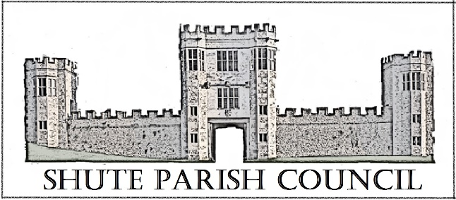

Colhayne Close, Colhayne Lane, Shute nr Axminster Devon, EX13 7QQ
Parish Clerk - Carol Miltenburg
tel:- 01404 831080 e mail:- clerk@shute.eastdevon.gov.uk

The Councillors were summoned to attend a meeting of Shute Parish Council held at Whitford Hall on Thursday December 7th, 2017 starting at 7.30pm. The following matters were discussed.

Those present Cllr Paddy Magrane, Bill Marshall, Richard Orsman, John Pearce, David Plowman, Peter Rugg (Chairman), Ella Sweetland, Rick Wood. Cllr Marshall took the Chair for the meeting. One member of the public was present.

- No apologies for absence or declarations of interests were made. Cllr Marshall welcomed everyone present on behalf of Cllr Rugg.

- The Minutes of the meeting of November 9th, 2017 were approved by the Council and signed by Cllr Marshall.

- Matters arising from previous minutes. Dog poo bin – Clerk to order from EDDC. Phone Kiosk – the Clerk has written to Mr Hammond for permission to cross his land to remove the kiosk. Having laid the wreath at the War Memorial Cllr Marshall thanked Cllr Rugg for instigating the handrail at the memorial.

- Public Forum – no questions or comments were raised.

- Finance. Payments to be made – C Miltenburg expenses £111.21(Ink & cable); Cllr David Plowman £52.98 (stationery re car park committee). Payments received – small interest amount. Precept 2018/2019 - the Council agree that the precept should remain at £4,800.00 for the year 2018/19. Hitchcock Trust insurance renewal from Came & Co £280.00 – it was agreed to contribute 50% of the cost and invoice the balance to Kilmington Parish Council. The Council noted the new external auditor – PKF Littlejohn LLP. The bank statements were presented. It was agreed to discuss the use of the councils 3rd account at the next meeting.

- Reports from Parish, District & County Councillors and Police – none were received.

- Burial Ground. Cllr Wood updated those present on the meeting held in the afternoon of 7th December. The Council approved the purchase of a new burial book from Axminster Print bound in calf leather (cost £170) Cllrs Magrane and Orsman proposed and seconded. The suggestion of repairing the wall adjacent to the graveyard to create a memorial wall and install a gate. Clerk to write to the Church Warden. The next burial ground meeting will be held on site in January / February. Minutes are attached.

- Car Park. Update by Cllr Plowman. He gave information on the meeting at the school with the representative from DCC. This was not altogether positive and the school will now take the lead on making the front playground suitable for parking. They still want to go ahead with the lease on the land behind the school. Cllr Plowman has agreed to become an acting school governor for this project. The Council were concerned by the very negative and combative attitude of the DCC representative at this meeting. Cllr Marshall thanked Cllr Plowman for continuing with the project and the hours he has put into it so far.

- Planning 17/2797/FUL - Shute Hill Farm Shute Axminster EX13 7PY. The Council had no objections Cllrs Magrane and Wood proposed and seconded. Clerk to write to EDDC concerning the difficulties of downloading plans. It was noted that The Forge has had planning permission approved for holiday accommodation.

- Correspondence received. Letter from Whitford Village Hall Committee - Cllr Marshall agreed to be the Councils representative on the committee. Proposed and seconded by Cllrs Magrane and Wood. The Energy Savings Network are due to give a 30 minute talk to help those in fuel poverty at the Whitford Hall in the New Year. EDDC e mail re Community Building Fund – details were read out. EDDC are easing restrictions on street trading in the area.

- Highway Matters. E mail from DCC re flooding. It was noted that Lodge Lane between Lexhayne Lane and The Oaks is still flooding after rain, also it was noted that the pipe under Hampton Lane is becoming blocked. Clerk to notify DCC. Clerk to write to residents of Seaview re salt bin. Cllr Marshall thanked Mr Sweetland for his continued work as snow warden.

- Any Other Business. Cllr Marshall thanked the Clerk for her work on behalf of the Council.

Date, time & place of next meeting:- Thursday, January 25th 2018 at Umborne Hall starting at 7.30pm
The meeting ended at 8.45pm.

