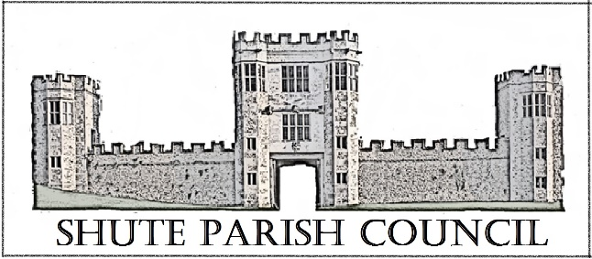

Colhayne Close, Colhayne Lane, Shute nr Axminster Devon, EX13 7QQ
Parish Clerk - Carol Miltenburg
tel:- 01404 831080 e mail:- clerk@shute.eastdevon.gov.uk

The Councillors were summoned to attend a meeting Shute Parish Council held at Shute School on Thursday November 9th, 2017 starting at 7.30pm.
The meeting was moved to St Michael’s Church, Shute as the Council were unable to gain entry to the School, the meeting began at approximately 7.50pm. The following matters were discussed.

Those present:- Cllrs Paddy Magrane, Richard Orsman, David Plowman, Peter Rugg (Chairman), Ella Sweetland, Rick Wood. Two members of the public were also present.

- Apologies for absence were received from Cllrs Bill Marshall and John Pearce. No declarations of interests were made.

- The Council approved the Minutes of the meeting of September 28th, 2017 and these were signed by the Chairman.

- Matters arising from previous minutes. Cllr Marshall has received the wreath and will lay it at the War Memorial on Remembrance Sunday. Dog poo bin an e mail from EDDC was shown the cost of the bin will be £70 plus installation (up to 2 hours) plus £200 per year for emptying 3 times per week. Clerk to obtain grant (if possible). Clerk to order from EDDC. Dog fouling stickers were given to the Councillors to distribute.

- Public Forum – no questions were raised.

- Finance. Payments to be made Royal British Legion £15.00 wreath. Payments received none. The proposed budget for 2018/18 will be distributed prior to the next meeting. The bank statements were available to the Council. The Council agreed the payment.

- No reports from were received from District/County Councillor. The Clerk reported that the Police were going to contact the underage motorcycle rider in Shute. Cllr Orsman reported that he had done the required returns to the Charity Commission for the Hitchcock Trust.

- Burial Ground update. It was agreed that the Burial Ground Committee should meet on December 7th at 2pm at Cllr Orsman’s home. The Clerk is to ask Mr Wareham to collect the leaves etc in the Burial Ground. The Clerk reported that the noticeboard in the Church porch has been covered in cork tiles and the Burial Ground regulations have been put up. The Clerk is still looking for a Burial Book.

- Car Park. Update – Cllr Plowman advised that there have been 2 meetings and has had further confirmation that the land behind the school is available for lease but as yet nothing has been received from the land agent. The next stage Is to survey the area in front of the school for a parking layout and to look at perimeter fence for the leased field. He also advised that the volume of work will mean that some form of remuneration will have to be made.

- Planning
17/1821/COU - Land Opposite Shute Garage Shute - Amendment. The Council reviewed the new documentation and reiterated their original opinion especially with respect to the proposed entrance / exit on to the A35.
Shute School - Granted – the Council noted the application result.
17/2314/FUL – Rowlands, Shute - no objections

- Correspondence received.
Salt Bin adjacent to East Lodge / Bettys Ground. The Council agreed that if the residents would purchase a suitable grit bin that the would fill it. Clerk to write.
Access to common land in Shute woods. The Council has been contacted about access to the common land being possibly blocked. Clerk to check with the Commons officer at EDDC.
CPRE – It was decided not to take out a membership.
Healthwatch – Voices magazine - noted
Axminster Heritage – the Council noted their recent letter.

- Highway Matters. Cllr Wood reported that Colhayne Knapp was due to be patched by DCC before the end of the financial year. It was noted that Lodge Lane will be closed for a day. Cllr Wood reported that the road team has done a lot of pot hole filling especially on Haddon Road and near Watchcombe. In respose to our e mail to DCC re cutting hedges and clearing ditches near Shute Pillars – the ditches are the responsibility of the land owner as are the hedges. DCC have viewed the area and did not feel them to be a problem. The pathway between Shute Pillars and the A35 will be cleared and cut back under the Community Payback scheme. Mr Keith Sweetland has agreed to continue as the Snow Warden.

- Any Other Business. Several members of the Council would be unable to attend the scheduled meeting on December 14th, 2017 – Cllr Orsman will check the availability of Whitford Hall on other dates. The clerk thanked Cllr Orsman for taking over the Hitchcock Trust. Cllr Sweetland reported that there has been some damage to the glass in the telephone kiosk at Seaton Junction.
** The date of December 7th was agreed in the following days **
Date, time & place of next meeting:- Thursday, December 7th starting at 7.30pm at Whitford Hall
The meeting concluded at 9.30pm

