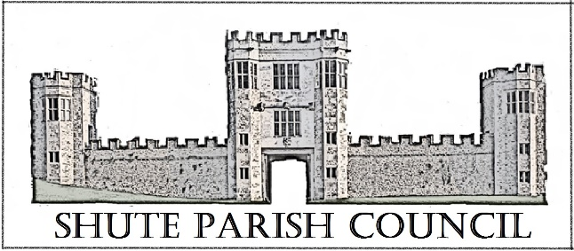

Colhayne Close, Colhayne Lane, Shute nr Axminster Devon, EX13 7QQ
Parish Clerk - Carol Miltenburg
tel:- 01404 831080 e mail:- clerk@shute.eastdevon.gov.uk

The Councillors were summoned to attend a meeting Shute Parish Council at Umborne Hall on Thursday May 25th, 2017 starting at 7.30pm. The following matters were discussed.

Those present:- Cllrs Paddy Magrane, John Pearce, David Plowman, Peter Rugg, Ella Sweetland, Rick Wood. Cllrs Ian Chubb (DCC & EDDC) & Andrew Moulding (EDDC). 2 members of the public – Mr & Mrs Prideaux.

Annual Meeting

1 Election of Chairman – Cllr Rugg was proposed by Cllr Plowman and seconded by Cllr Wood.

2 Election of Vice-Chairman – Cllr Marshall had previously agreed to stand again – this was unanimously accepted by the Council.

3 Election of other Representatives. Trustees of Hitchcock Trust – The Clerk is unable to continue as administrator due to work commitments. Kilmington PC have previously declined to take over the administration role. It was agreed that this should become a paid role and the post should be advertised. It was agreed to contact Kilmington PC with a view to the funding to come from the ‘Parishes Together Fund’ to prepare the new governance structure for the Trust. (Clerk to contact Kilmington PC)
Planning Committee – It was agreed to continue as previously whereby Councillors review applications in their own location except when contentious; Burial Ground Committee & Car Park Committee to continue as previously.

Parish Council Meeting

- Apologies for absence were received from Cllrs Marshall and Orsman. Declaration of interests Cllr Rugg – Item 11.

- The Minutes of the meeting of April 20th, 2017 were approved by the Council and signed by the Chairman.

- Matters arising from previous minutes. BT Phonebox. The Clerk confirmed the box at Seaton Junction now belongs to the Council having received the signed contract back from BT. It was noted that the payphone box in Whitford has been bought by the owner of the land it stands on. The Council complimented Cllr Pearce for his repair of the noticeboard at Patches. The new board at the war memorial will be replace when Cllr Marshall and Orsman return from holiday.

- Public Forum. It was commented that 2 dogs from Ashes House had escaped and got into the school grounds. The Council were very concerned by this incident. (Clerk to contact Dog Warden).

- Finance. Approve the Parish Council annual accounts. a) The Council agreed the statements in Section 1 of the Annual Accounts and the Chairman signed the declaration. b) The Council agrees the accounts as detailed in Section 2 of the Annual Accounts and the Chairman duly signed the declaration.
Insurance – it was agreed by the Council to continue with Came & Co.
Payments to be made Came & Co £280.00 (insurance). Payments received - £500 DCC Highways.

- Reports from District & County Councillor – The Council congratulated Cllr Moulding on his appointment as Chairman of EDDC. He told the Council of his Chairman’s Garden Party at Knowle on July 16th where he wanted the “sports champion” of the parish to come as the parishes representative. The Council agreed to find a suitable person.
Cllr Chubb reported that he has now taken over as the County Councillor for the Parish. He is getting to know the parishes in his area which stretch to Whimple and will get to as many meetings as possible. But many evenings have multiple parish council meetings. All have the same problems ie roads etc. He is trying to get greater funding for pothole repairs in this area as the geology may make the roads more prone to them – DCC Highways are investigating. He confirmed that the EDDC office move from Sidmouth to Honiton should take place in the middle of next year. He reported that the parish will go on the full recycling scheme shortly and the green bags will be delivered shortly. The collection lorries are fitted with cctv.
Police – No crimes have been recorded in Shute parish in April 2017.

- Burial Ground. Update and to approve charges for 2017 – the Council agreed to continue with the charges and conditions already in place. It was agreed that the Clerk should obtain the burial record applicable to the Burial Ground from the Church.

- Car Park. Cllr Plowman updated the Council on the car park committee and advised that progress was being made in locating possible sites.

- Correspondence. CPRE – Our Outdoors Competition 2017 – noted. Seafarers UK – Merchant Navy Day – noted.

- Highway Matters. The Clerk confirmed that the grant from DCC Highways was in. The new Highways officer for the parish is Helen Selby. Noted.

- Planning. APP/U1105/W/17/3173642 Appeal by Mr & Mrs Rugg. (Cllr Rugg left the room). The Clerk declared an interest and advised that the other households in Colhayne Lane had been seen in the previous 48 hours and all supported the application. The Council discussed the appeal at depth and after taking advice from Cllr Chubb on the technicalities of the planning rules concerning redundant agricultural buildings they felt that they could remove their objections.

Site adjacent to Whitford monitoring station. The Clerk advised that PCSO Widger had been contacted about activity at the site. There had been a lengthy conversation with the EDDC Enforcement Officer who has visited the site with the owner after the report and reiterated to the tenant that it is not permitted to stay overnight at the premises. Any future breeches should be reported via the Clerk to EDDC. It was also noted that the site is classified as B2 General Industrial since the late 1980’s and is not considered agricultural.

- Any Other Business. None

Date, time & place of next meeting:- July 6th 2017 at Shute School starting at 7.30pm

