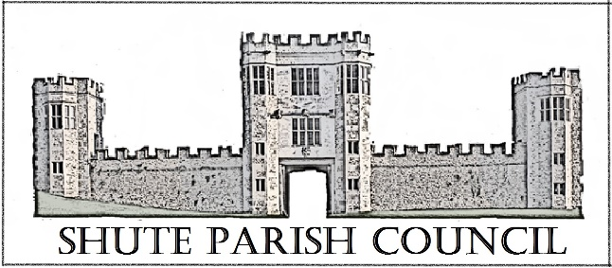

Colhayne Close, Colhayne Lane, Shute nr Axminster Devon, EX13 7QQ
Parish Clerk - Carol Miltenburg
tel:- 01404 831080 e mail:- clerk@shute.eastdevon.gov.uk

Those present:- Councillors Angela Choake, Bill Marshall, David Plowman, Ella Sweetland & Mary Thomas and Carol Miltenburg – Clerk. Apologies were received from Cllrs Magrane, Orsman and Cllr Iain Chubb (EDDC & DCC).
The Councillors were summoned to attend a meeting Shute Parish Council held at Whitford Hall on Thursday May 28th, 2021 which started at 7.30pm. The following matters were discussed.

Annual Meeting of the Council

1 Election of Chairman. Cllr Marshall was nominated to continue by Cllr Thomas and seconded by Cllr Plowman. Cllr Marshall accepted the nomination & signed of Acceptance of Office.
2 Election of Vice-Chairman. Cllr Sweetland agreed to continue and was proposed by Cllr Marshall and seconded by Cllr Choake. She duly signed the Acceptance of Office.
3 Election of other Representatives. Trustees of Hitchcock Trust the Clerk agreed to continue as trustee and Cllr Orsman will be asked shortly; Planning Committee – to continue as previously; Burial Ground Committee Cllrs Sweetland, Choake and the Clerk agreed to continue and Cllr Orsman will be asked shortly.

Parish Council Meeting

- Apologies for absence – see above & declarations of interests were received from Cllr Plowman re item 10.

- The Minutes of the meetings of April 22nd and 29th 2021were approved and signed by the Chairman

- Matters arising from previous minutes. Clerk to chase re car park at Shute woods. Cllr Marshall updated the Council on the tyres recently dumped at Whitford Bridge and advised it has happened several times locally. The Clerk showed the Council the new laptop computer which has been purchased.

- Public Forum – None were present.

- Finance. Payments to be made – Came & Co £349.36 Insurance; C Miltenburg £637.01 laptop purchase; Whitford Village Hall £14.00 hire charge. The bank statements were shown to those present.
It was agreed to pay for the hire of the Whitford Hall on their invoice rather that pay by a donation as has been done previously.

- There was no report from Cllr Chubb as he could not attend. It was felt the new Police newsletter was very good especially the contact numbers.

- Burial Ground. The Council reviewed the charges for 2021. Cllr Thomas proposed that the charges remain the same in view of the finances etc and it should be reviewed again in 2022. Cllr Marshall seconded. Cllr Sweetland asked if a tap could be installed in the Ground to supply water for flowers. I was felt that it was too difficult to do this direct from the church but that there was a main in the lane that maybe could be used. Clerk to contact South West Water to get an idea of charges.

- Shute Barton / Car Park. The Council discussed the situation with the Car Park and the attitude of the National Trust. It was felt they will make any proposal for a car park very difficult. The Clerk advised about the chimney pot that has been placed on The Gatehouse (a listed building) during the recent repairs without any planning permission. The EDDC Enforcement Officer has confirmed that the offending pot will be removed. The National Trust have advised that Landmark Trust will be in contact with the Council. Shute School – The new classroom at the school which was due to be installed in c2019 has never materialised and the Council wanted to know the reasons. It was also noted that the childrens toilets are still not fully functioning. Clerk to contact Cllr Chubb to establish why.

- Highway Matters. Purchase of tarmac buckets. The Road Warden requires a new pallet load of buckets. Clerk to apply through the DCC grant funding scheme. The Clerk has has received reports of unwanted activity in the car parking area at Whitford Bridge. Clerk to contact PCSO Widger.

- Planning. 21/0240/FUL - The Granary Hampton Court Whitford The Council had no objections to this application but feel drawings of the west side of the alterations being made should be provided.
17/1445/VAR - Station Buildings, Seaton Junction – the Council discussed the progress of the development of the buildings as the S106 payment is still outstanding. This is due to the application being subject to the applicant entering into a deed of variation to the s.106 agreement on the original permission (14/0143/FUL). This Deed of Variation has not yet been agreed. Cllr Chubb will chase this.

- Correspondence. None

- Any Other Business. None.

Date, time & place of next meeting:- July 8th – venue to be confirmed - starting at 7.30pm

The meeting ended at 9pm.

